Lab1: DC Circuits
(You may adjust and use this draft as your lab report)
Student 1
Student 2

Series Circuit: Use a DC power supply (Vs) and select two resistances to calculate and measure the required quantities.

Circuit | Calculation using Multisim | Lab Measurement
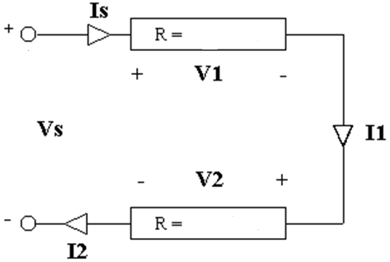 | Vs =  Is =  V₁=  I₁ =  V₂=  I₂ =  Ps =  P_{R1} =  P_{R2} = | Vs =  Is =  V₁=  I₁ =  V₂=  I₂ =  Ps =  P_{R} =  P_{R2} =

Parallel Circuit: Use a DC power supply and select three different resistances to calculate and measure the required quantities.

Circuit | Calculation using Multisim | Lab Measurement
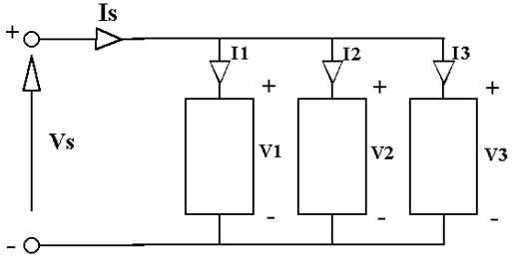 | Vs =  Is =  V₁=  I₁ =  V₂=  I₂ =  V₃=  I₃ =  Ps =  P_{R1} =  P_{R2} =  P_{R3} = | Vs =  Is =  V₁=  I₁ =  V₂=  I₂ =  V₃=  I₃ =  Ps =  P_{R1} =  P_{R2} =  P_{R3} =

Combinational (Series and Parallel) Circuit: Use the following table to design a proper combinational circuit and measure its various quantities

Circuit | Calculation using Multisim | Lab Measurement

Procedure:
- Use Multisim to draw the above three tasks and calculate the required quantities.
- After calculating all the above quantities prove the case of KVL and KCL.

