Mid-Term Exam -- SEG 2101
Wednesday, March 1, 2000

SOLUTIONS

Question 1 (22 points)
The specification of the “Daemon Game” in SDL is given in Annex A (the version presented in class). This version of the Daemon Game supports several simultaneous players (users). Give a simplified specification of this game which only supports a single player (user) at a time. In such a specification, one does not need the process Monitor (shown on Fig.7 in Annex A), as indicated in the revised Fig. 7 in Part II of Annex A.

Please indicate changes on the revised figures 7 and 21 in Part II of Annex A by crossing out elements of the specification which are not needed any more, and by adding elements which must be added in order to obtain a simplified version of the game which supports only a single user at a time. (Please answer this question in Part II of Annex A)

Solution: see next page

Comments:
- As suggested in the original text, the Monitor is not required. Since we assume that there is only one user process at a time in the environment, we do not need to know its identity. Therefore the variable userset in the Monitor is not required any more. Also we do not have to indicate the identity of the user in the output commands of the Game process using the TO clause. It follows that we do not need the player variable in the Game process.
- The purpose of the Gameid signal is to send the identity of the Game process to the user process when a new game starts. Also this signal is not needed any more since there is only a single Game process.
- If we decide to change the interactions as seen by the user as little as possible, I would suggest only to eliminate the Gameid signal and leave the other signals as in the original specification. This is the approach taken in the solution in the Annex. However, one could also decide that the Endgame signal is not required any more, because the Newgame signal could automatically end the currently active game and start a new one. However, when we leave the Newgame signal in the specification, this means that several games may be played one after the other. In this case the end of a game should not lead to the termination of the process (as indicated by the cross in the original specification). One student decided that only one game would be played: he eliminated the Newgame and Endgame signals all together, thus simplifying the situation further (this is also OK).
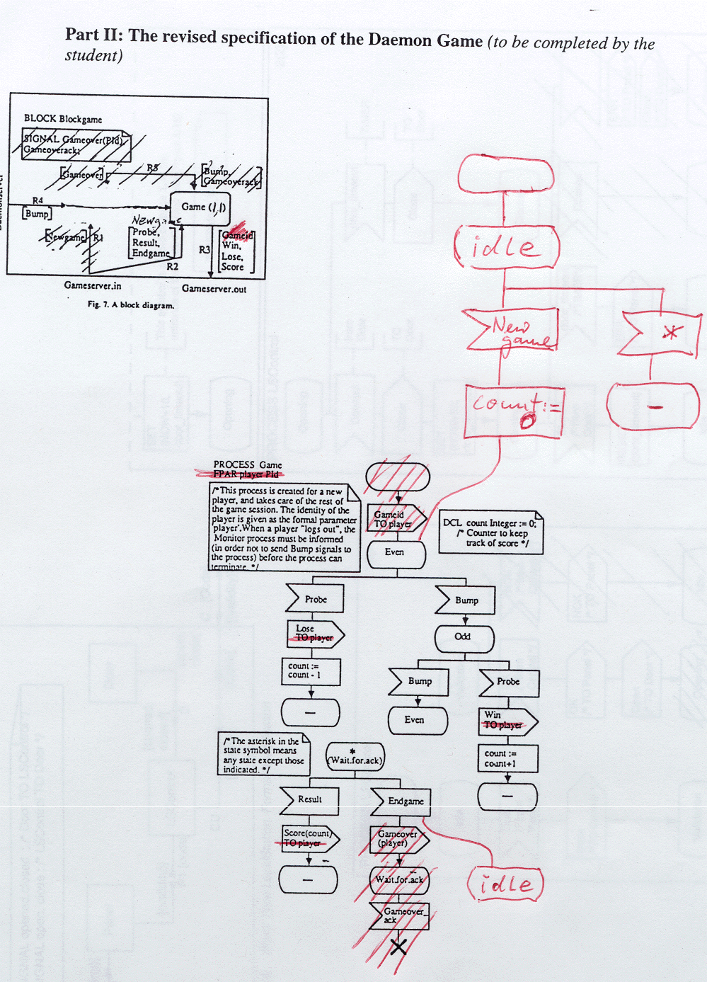

Question 2 (16 points)

Figure 4.10 in Annex B shows the block structure of a LocalStation, including the block LSControl. Figures 4.16 and 5.10 in Annex B provide the SDL specification of the dynamic behavior of the process LSControl which is contained in the block with the same name.

Please, provide MSC diagrams which represent use cases that could be used to test the behavior of an implementation of the LSControl process and cover all branches of the SDL specification that are not crossed out on the figures. These MSC diagrams should include the processes Panel, LSControl, Door, and CentralStation.

Note: To indicate any time delays in the MSC diagrams, you should use the notation shown in Figure below, where the notation "T ≤ 1 sec" means that the time interval indicated by the curly brace is smaller than 1 second.

Solution: (next page)
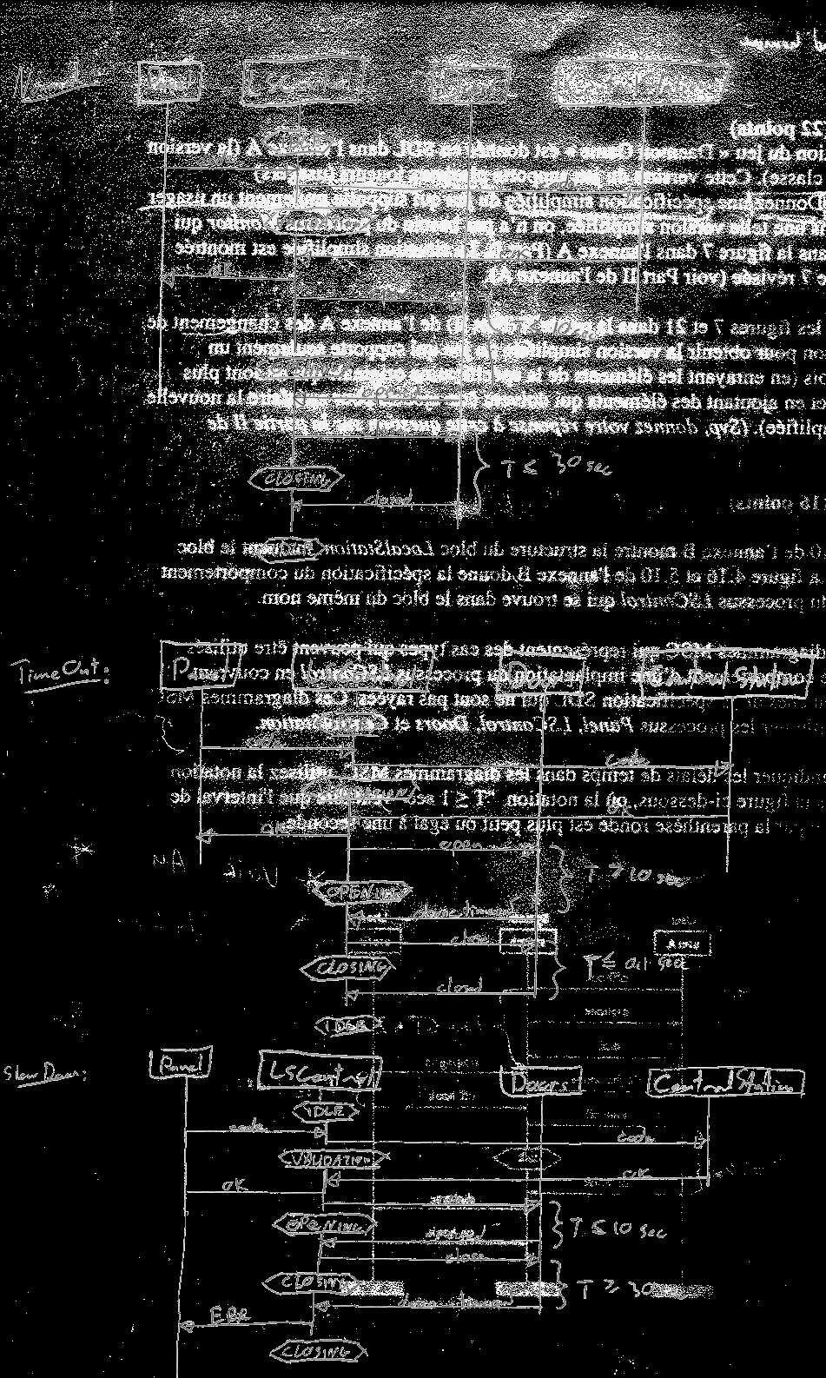

Comments:
- The sign "-" means "back to the same state" in SDL.
- Some people did not use the proposed notation for the timing properties. Timing properties are important here since timers are involved.
- It was not necessary to include the time-out interactions explicitly in the diagrams. What counts are the ting properties of the externally visible interactions.
- Some people included the scenario where first the timeout in the Opening state occurs and then a timeout in the Closing state. But such a scenario cannot occur since the timer is not set when the Closing state is reached through the branch of the first timeout.

Question 3 (16 points)
We consider the following grammar:
S -- > 1 S | A | 0 B
A -- > B | 1 A 1 | 0 2
B -- > 2

Question 3(a): Write down a syntax tree for the sentence 1 1 2 1 generated by this grammar. (3 points)
Solution:
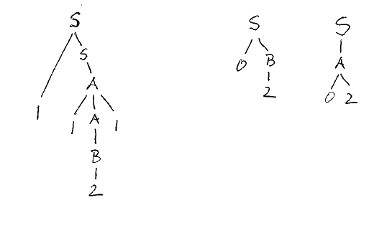
Question 3 (b) : Enumerate all sentences generated by this grammar which have a length of 1, 2 or 3 characters. (4 points)
Solution: 2 , 0 2 , 1 2 , 1 2 1 , 1 0 2 , 1 1 2

Question 3(c) : Is this grammar ambiguous ? -- Explain why or why not. (4 points)
Solution: Yes, because the sentence 0 2 allows for the following two syntax trees:
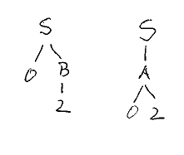

Question 3(d) : Is this grammar LL(1) ? -- Explain why or why not. (5 points)
Solution: No, because the first and second alternative for S, namely 1 S and A have a common terminal, namely 1. First (1 S) = {1} and First (A) = {2, 1, 0}.

Question 4 (5 points)

Please write down a grammar which generates the language consisting of all sentences of the form a^{n} c b^{n} or a^{n} b c a b^{n} , where n is a non-zero positive number and a^{n} and b^{n} represent n consecutive “a” characters and “b” characters, respectively.

Solution: S --> a S b , S --> acb , S --> abcab

Comments:
- The value of n for a^{n} and b^{n} is the same in this notation; that is, there are the same number of a at the beginning as there are b at the end. Since n must be non-zero, the shortest sentence is acb.
- (b) If you take a grammar like S --> A X B , X --> acb , X --> abcab , A --> a A | a , B --> b B | b then the number of a and b are not related to one another. The rules for A and for B are applied independently of one another, and one does not obtain the same number of a and b.

Question 5 (5 points)

Please give a regular expression for the language accepted by the following accepting automaton (with initial state 1 and only accepting state 2):
The corresponding regular expression is:

Solution: a* c b*
Comments: Some people have put a number of parenthesis, brackets or braces around the a and b. There is no good reason to do so. You would not write an arithmetic expression of the form {a} + (b)² (instead of a + b² ) or would you ??

Question 6 (10 points)

Give an accepting automaton for the following language: A sentence of the language begins with an “a” or “b” character, then contains one or several “c” characters and terminates with an “d” or “e” character.
Solution:
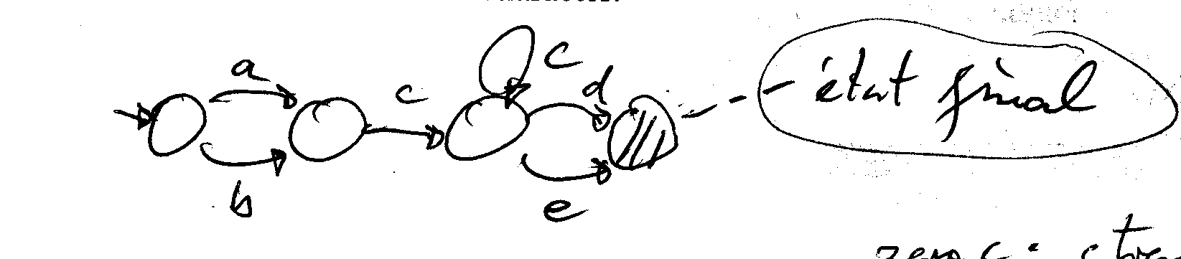
Comments:
- You should mention what the accepting states are. In this case only the last one.
- Some people had the second and third state combined into a single state. In that case a sentence without any c could be accepted (which is an error).
- Some people had the self-loop accepting c not in the third state but in the second state. This results in the same sentences, but the automaton becomes nondeterministic. It is nondeterministic because in the second state, there are two transitions for the same input leading to different state; therefore it is not evident which choice the automaton should do when a c input is encountered. The choice will have an effect of what sequence of input can be accepted afterwards, therefore the choice can only be made by looking further ahead. The automaton given above is deterministic, and its execution is straightforward. It is suggested to avoid nondeterministic automaton, as far as possible. By the way, there is a theorem that states that for any nondeterministic accepting automaton one can find an equivalent deterministic one (equivalent meaning, one that accepts the same set of sentences).

Question 7 (6 points)
For a given grammar, the problem of recognition is to determine whether a given sentence belongs to the language defined by the grammar. For a class of grammars (as for example the class of LL(1) grammars), the problem of recognition is to determine, for a given grammar of that class and a given sentence, whether the sentence belongs to the language defined by the given grammar.

In class, the following statement was discussed: The problem of recognition is undecidable for the class of general Chomski grammars. What does this statement mean ? – Please explain.

Solution:
The statement "the problem of recognition for the general class of Chomski grammars is undecidable" means that it is impossible that there exists an algorithm which for a given general Chomsky grammar and a given sentence decides whether the sentence can be generated by that grammar. (Note: An algorithm always terminates.)

Comments:
- I also gave some points for a correct explanation what the class of general Chomsky grammars are, and for imprecise statements such as "not possible to decide" or "because infinitly many sentences can be generated".
- By the way, there exists a procedure for checking whether a given sentence can be generated by a general Chomsky grammar (by simply generating all sentences that can be generated by the grammar), but such a procedure will not terminate in the case that the sentence cannot be generated by the grammar.

Question 8 (20 points)

We consider an LL(1) grammar of a very simple programming language which contains the nonterminals <statement>, <exp>, etc. The syntax for the <statement> nonterminal is as follows:
<statement> -- > <ident> := <exp> ;
| IF <exp> THEN <statement> ;

Please write (in Java, C++ or Pascal) the skeleton of a syntactic procedure, called statement, which performs the syntax analysis of a statement of this language. This procedure should be written in such a way that it could be used in a compiler for this language, which is written according to the principle of recursive descent syntax analysis.

We assume that the syntactic procedures of the compiler use an object lex which offers a method nextToken() which reads the next lexical token and an attribute token which always contains the last token read. (Note: In Pascal, you may assume that a global procedure nextToken and a global variable token exist). We assume that at the entrance to a syntactic procedure the first token (by which the corresponding nonterminal starts) is already read. We also assume that the following constants have been declared; they represent the tokens corresponding to the terminals of the language: IDENTTOKEN, IFTOKEN, THENTOKEN, ASSIGNTOKEN, SEMICOLONTOKEN, etc.

Comments:
- As usual, <exp> is another nonterminal, besides <statement>. Therefore we assume that a similar recursive procedure named exp exists.
- I think that the original text implies that token contains the next lexical token and that this value advances by one lexical unit whenever the method nextToken is called. We should assume that the first token generated by the nonterminal is already in token when the procedure corresponding to that nonterminal is called.

Solution: I would write the following program in Java

void statement() {
if (lex.token == IDENTTOKEN) do {
lex.nextToken();
if (lex.token == ASSIGNTOKEN) do {
lex.nextToken();
exp();
if (lex.token == SEMICOLONTOKEN) do {lex.nextToken(); return }
else error(" ; expected") }
else error(" := expected") }
else if (lex.token == IFTOKEN) do {
lex.nextToken();
exp();
if (lex.token == THENTOKEN) do {
lex.nextToken();
statement();
if (lex.token == SEMICOLONTOKEN) do {lex.nextToken(); return }
else error(" ; expected") }
else error(" THEN expected") }
else error(" IF or idendifier expected") }
}

ANNEXES
